Romina ehsani

4) Internal oscillators and their usage :

To save on external components, many PICs now include an internal oscillator. In the '690, this runs at 8 MHz, or lower frequencies by division, with a default of 4 MHz selected if the OSCCON register is not initialized and the internal oscillator selected in the [configuration word](https://www.sciencedirect.com/topics/engineering/configuration-word). More recently, 32 MHz internal oscillators have been introduced. The frequency can be calibrated using an internal register if a more accurate clock is needed. However, an external crystal clock will still provide maximum accuracy. In recent chips, multiple clock modes are available to optimize the tradeoff between clock speed, accuracy and [power consumption](https://www.sciencedirect.com/topics/engineering/electric-power-utilization). Many chips now have an additional internal oscillator, an internal 31 kHz clock, which can be connected to Timer 1 as an independent time base and drives the power-up timer system.

No external components are required: You can safely assume that the frequency is well chosen since the oscillator was designed by the same people who designed the rest of the microcontroller. Also, the salient performance specs—e.g., initial accuracy, duty cycle, temperature dependency—are (hopefully) right there in the datasheet.

The dominant disadvantage with internal oscillators is the lack of precision and frequency stability. The baseline frequency depends on the values of the passive components that make up the oscillator circuit, and the tolerances for the values of these passive components are not particularly tight. Furthermore, capacitance and resistance are influenced by ambient temperature, so internal RC oscillators experience temperature “drift”—i.e., changes in temperature lead to changes in frequency. With older microcontrollers, the internal oscillator might have tolerance as bad as ±20%. However, a newer device can give you ±1.5% (or better), which is accurate enough for RS-232 communication and even (in conjunction with clock-recovery circuitry) for USB.

Another way to expand the capabilities of an internal oscillator is manual “trimming”—if your microcontroller includes a trimming/calibration register, you can adjust the frequency by modifying the value in this register. This is a perfectly practical technique for low-quantity designs: Simply measure the clock frequency with an oscilloscope or frequency counter and then trim the oscillator accordingly.

A variation on the internal-oscillator theme is the phase-locked loop (PLL). A PLL allows a low-quality, high-speed internal oscillator to benefit from the stability and precision of an external oscillator. In general, a PLL doesn’t help you to avoid external components because it requires a reference clock that is usually derived from a crystal. An exception, though, is when you have a high-quality clock somewhere on the PCB but don’t want to use it for the microcontroller because it’s too slow—you could use a PLL to multiply this clock up to an acceptable frequency.

5) The LED current must be less than the maximum permitted for your LED. For standard 5mm diameter LEDs the maximum current is usually 20mA, so 10mA or 15mA are suitable values for many circuits. The current must be in amps (A) for the calculation, to convert from mA to A divide the current in mA by 1000.

|  |  |  |  |  |  |  |
| --- | --- | --- | --- | --- | --- | --- |
| Power Supply Voltage | LED Color | LED Vf | LEDs in series | Desired Current | Resistor (calculated) | Resistor (rounded) |
| 3 V | Red, Yellow, or Yellow-Green | 1.8 | 1 | 25 mA | 48 Ω | 51 Ω |
| 4.5 V | Red, Yellow, or Yellow-Green | 1.8 | 2 | 25 mA | 36 Ω | 39 Ω |
| 4.5 V | Blue, Green, White, or UV | 3.3 | 1 | 25 mA | 48 Ω | 51 Ω |
| 5 V | Blue, Green, White, or UV | 3.3 | 1 | 25 mA | 68 Ω | 68 Ω |
| 5 V | Red, Yellow, or Yellow-Green | 1.8 | 1 | 25 mA | 128 Ω | 150 Ω |
| 5 V | Red, Yellow, or Yellow-Green | 1.8 | 2 | 25 mA | 56 Ω | 56 Ω |
| 9 V | Red, Yellow, or Yellow-Green | 1.8 | 4 | 25 mA | 72 Ω | 75 Ω |
| 9 V | Blue, Green, White, or UV | 3.3 | 2 | 25 mA | 96 Ω | 100 Ω |

Most small LEDs have a forward voltage in the range of 1.5 to 3 volts. Consider using 2 Volts for an estimate if you can’t find the exact value. Remember that in general the smaller LEDs will have a lower forward voltage. Most small LEDs have maximum on-current rating within the range of 10 milliamperes to 30 milliamperes. Consider for the most part that the bigger the LED is, the more current it will be able to carry without being damaged. Consider an estimate of 20 milliamperes for the maxumum on current if you can’t find the exact number. Calculate the voltage across the resistor for the series LED-resistor circuit. Subtract the LED’s forward voltage rating from the supply voltage used to power the circuit. For this example, with a supply voltage of 12 Volts and a LED forward voltage rating of 2 Volts, the voltage across the resistor will be 10 Volts, since 12 minus 2 is 10. Calculate the value of the resistor needed for the series LED resistor circuit. Divide the voltage across the resistor, obtained in the previous step, by the LED's maximum on current, obtained in step 3. For this example, the voltage across the resistor is 10 Volts and the maximum on current is 20 milliamperes. The resistance value is then 500 Ohms, since 10 divided 0.02 is 500.

1 2 3)

پورت های B0 تا B7 به عنوان خروجی تعریف شده اند. پورت A0 به عنوان ورودی متصل به دکمه تعریف شده است.

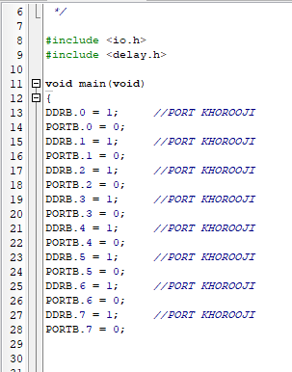

که در صورت فشردن دکمه به پاور وصل شده و مقدار یک را می گیرد که از این شرط برای چک کردن شروع روشن شدن led ها استفاده شده است. پس از فشردن دکمه و برقراری شرط، چراغ اول روشن شده و بعد از نیم ثانیه یا 500 میلی ثانیه چراغ اول خاموش و چراغ بعدی روشن می شود . این عملیات ادامه یافته تا به چراغ هشتم میرسد .

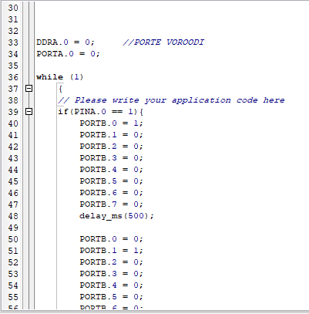

بعد از چراغ هشتم اگر چیزی ننویسیم حلقه از ابتدا شروع شده و چراغ اول روشن می شود. برای اینکه بازگشت از چراغ هشتم به اول و به ترتیب داشته باشیم ، باید از چراغ هشتم چراغ هفتم روشن شود. سپس چراغ ششم و به ترتیب این شرایط را اضافه می کنیم تا به چراغ دوم برسیم . حال با پایان یافتن حلقه ، عملیات از چراغ اول شروع شده و این حلقه تکرار می گردد.

